# Customer Brand Preferences Report

## Classifiers

### RANDOM FOREST

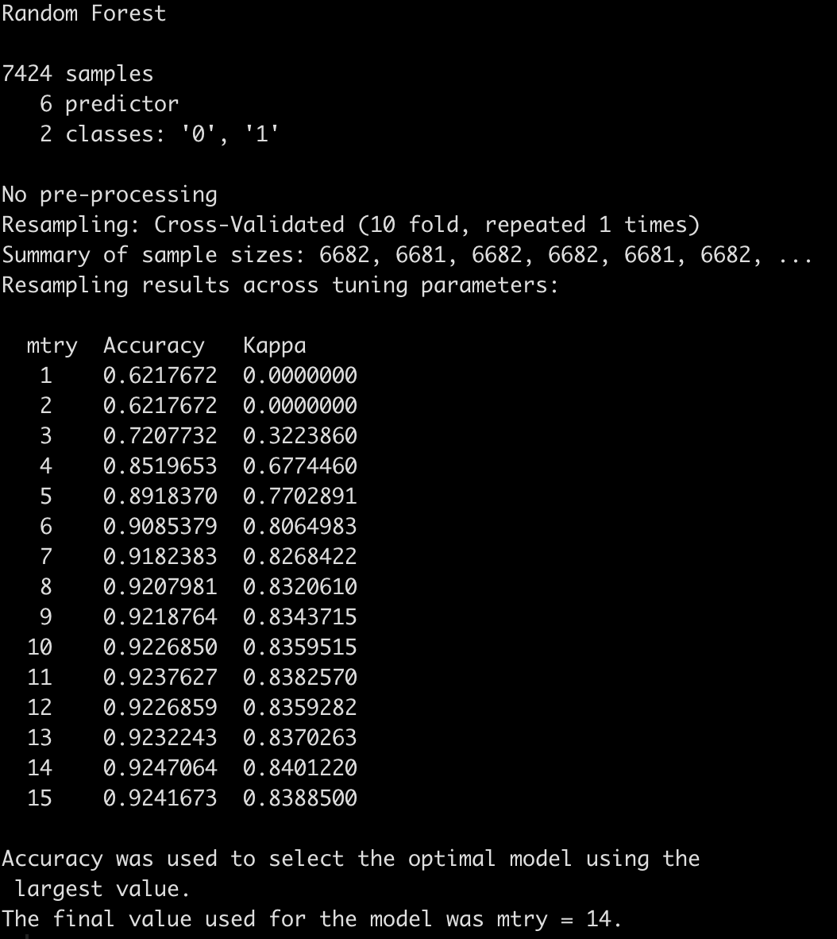

Test Results: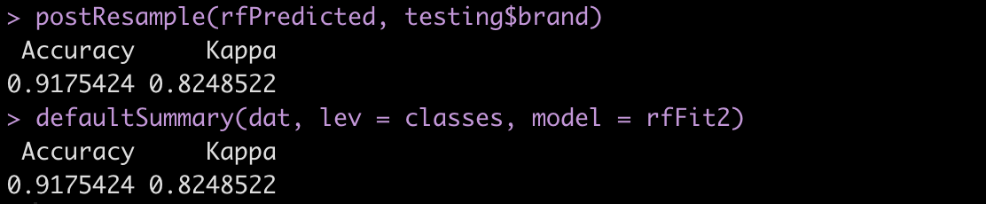

### Stochastic Gradient Boosting (GBM)

## 

Test Results:

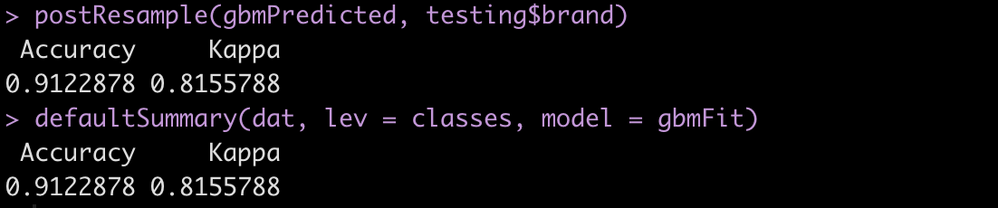

Using Random Forest model due to better accuracy and Kappa on test set.

## 

## Results

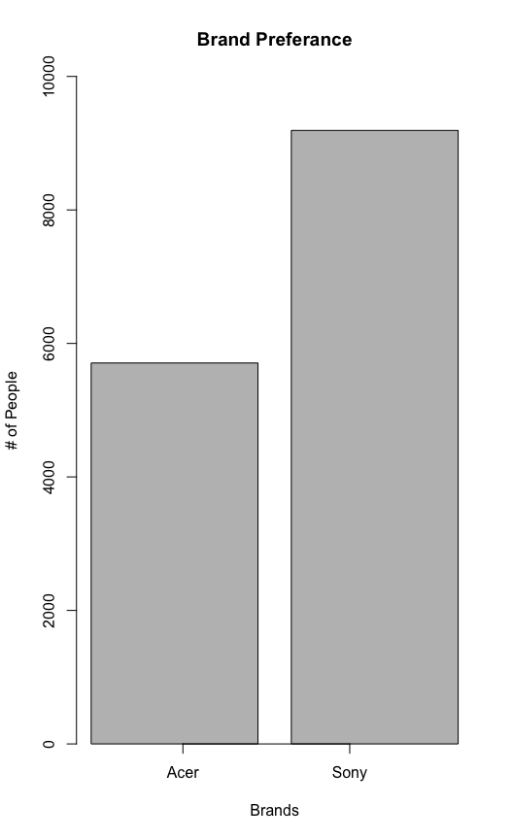

After using the random forrest model to predict the brand preferences in the incomplete survey data set, we totaled the total brand preferences of both the complete and incomplete data sets. The graph above details the split between the brand preferences of the complete data set. As can be seen, Sony is more preferred than Acer by larger than enough margin, where even taking in account the margin of error of the prediction model, we can safely say that a majority of persons taking the survey preferred Sony to Acer.